**Marketing Campaign**

**Customer**

# Segmentation

**By Group-5**

**Problem and Solution Summary**

## PROBLEM SUMMARY

▸ Customer segmentation is a crucial aspect of marketing operations for businesses and organizations

▹ Effectively use their money, time, and other resources to target the correct customer groups and provide customized communications and offerings

▸ We must divide the dataset of customers into groups based on similar characteristics of the customers ▸ Are there any issues with the data that we need to address before analyzing?

▸ What characteristics are common among the customers in the dataset to create customer groups?

▸ What variables can we create to further analyze the data?

▸ Which technique should we adopt to create clusters?

▸ How should we position our marketing campaigns and strategies to effectively target the given customer segments?

## FINAL PROPOSED SOLUTION DESIGN

▸ Data exploration

▸ Utilize Hierarchical Agglomerative Clustering to create customer segments

▸ Analyze 3 clusters created

▹ High-Income Customers

▹ Medium-Income Customers

▹ Low-Income Customers

▸ Make appropriate campaigns and offerings

**Executive Summary**

## KEY TAKEAWAYS

▸ At least one customer accepted the offer of all the campaigns. The offers from campaign 3 and 5 were accepted the most, and the offer from campaign 2 was accepted the least. More customers have accepted the offer in the last campaign compared to any of the offers from campaign 1, 2, 3, 4, and 5.

|  |  |  |  |  |
| --- | --- | --- | --- | --- |
| **Algorithm** |  | **Best Solution** | **Silhouette Score** | **Remarks** |
| K-Means | K = 5 |  | 0.13021374284739756 | In the elbow plot, the elbow is seen for K=3 and K=5. We used both of these K values to see which provides better results. We get deeper insights into different types of customers using K=5. |
| K-Medoids | K = 5 |  | 0.107528069592116 | Gives us similar clusters to K-Means algorithm. |

|  |  |  |  |
| --- | --- | --- | --- |
| **Algorithm** | **Best Solution** | **Silhouette Score** | **Remarks** |
| Hierarchical Clustering | * Euclidean distance and ward linkage * K = 3 | 0.25378332321341474 | The cophenetic coefficient has an average of  0.736922421650532 and highest coefficient of  0.8671371105092277, which means it is a pretty good measure of how faithful the dendrogram preserves the pairwise distance between the original unmodeled data points. |
| DBSCAN | Eps = 3 and min sample = 20 | 0.3398851568849134 | Highest silhouette average is 0.3398851568849134 for eps = 3 and min sample = 20. Only yields 2 clusters. |
| Gaussian Mixture Model | K = 5 | 0.14344403792681099 | Gives us similar clusters to K-Means and K-Medoids algorithm. |

## Cluster 0: High-Income Customers

▸ Consists of 583 customers

▸ Spend a lot and don't tend to make purchases through the company's company's website using a discount

▸ Average income of 74435.61

▸ Spends significantly more compared to the other clusters with an average of total amount spent of 1362.68 and

average of 71.11 spent per purchase

▸ Spend the most on wine, fruit, meat, fish, sweet, and gold products in the last 2 years

▸ Highest average for purchases made using a catalog or directly in store

▸ Average age of 48

▸ Don't have kids

▸ Highest average for accepting the offers in campaigns 1, 2, 3, 4, 5, and the last campaign

**Cluster 1: Low-Income Customers**

▸ Twice as big as the other two clusters with a total of 1072 customers

▸ Don't spend a lot and makes more purchases through the company's website using a discount

▸ Spend the least on average for all the products in this dataset

▸ Average income for customers in this cluster is 35708.22

▸ Spend an average total amount of about 50 fish, sweet, and gold products in the 112.64 and only 11.81 per purchase.

▸ On the younger side compared to the other two clusters with an average age of about 45.

▸ Have a small child in their household

**Cluster 2: Medium-Income Customers**

▸ Consists of 572 customers

▸ Spend a medium amount and seem to purchases through the company's website using a discount compared to the customers in the other two clusters.

▸ Average income for customers in this 58347.45

▸ Generally older as the average age is about 50

▸ Have a teenager in the household

▸ Average amount these customers spend in 759.70 with an average of 34.94 per purchase

▸ Make the most purchase

▸ Been with the company the longest

;

## KEY NEXT STEPS

▸ Create campaigns and other offerings that are personalized to the customers based on the clusters created

▸ Understand the successes and failures of prior campaigns and mimic what worked well

# Recommendations for Implementation

## KEY RECOMMENDATIONS AND ACTIONABLES

**▸ High-Income Customers**

▹ Mimic offerings in campaigns 1, 2, 3, 4, 5, and the last campaign

▹ Promote expensive products in catalogs and in stores

▸ **Medium-Income Customers**

▹ Offer discounts that can be used with purchases through the company’s website or in stores ▹ Promote offers that are suitable for a families and households with primarily teenagers

 ▸ **Low-Income Customers**

▹ Offer discounts that can be used with purchases through the company’s website

▹ Promote offers that are suitable for a families and households with primarily small children

## EXPECTED BENEFITS

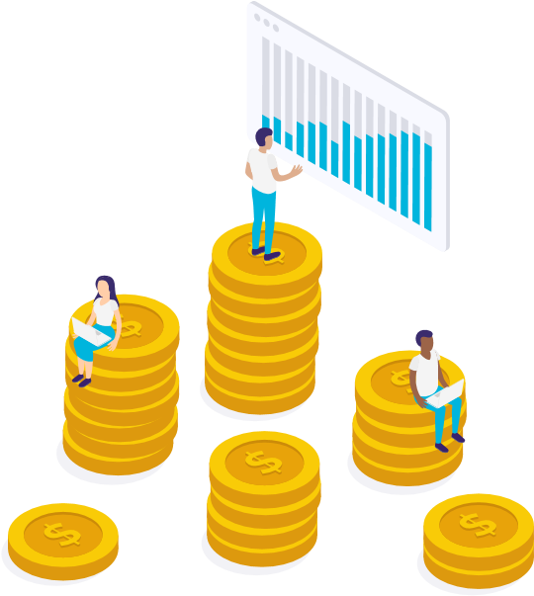 ▸ Deeper understanding of customers

▹ Needs, motivations, interests, spending habits, demographics and lifestyles

▸ More efficient marketing efforts and targeted campaigns ▸ Better return on investment

▹ Allows businesses and organizations to know how to effectively use their money, time, and other resources to target the correct customer groups

## KEY RISKS AND CHALLENGES

▸ Limited and/or expensive production

▹ It can be hard to produce a variety of products for each segment on a mass scale ▸ Costly and time consuming marketing

▹ Marketers have to consider all the segments in regards to the different needs, interests, habits, preferences and attitudes. Formulating and implementing several marketing strategies for different segments can take a lot of time.

▸ Wrong selection or change in the market

▹ Chance of selecting an irrelevant or very small segments and therefore, cannot sell its products or services properly ▹ Characteristics of the market may change due to a change in the customers’ behavior, buying habits, income, etc.

## FURTHER ANALYSIS / ASSOCIATED PROBLEMS

▸ Conduct further analysis for each campaign and why certain ones performed better with customers than others

▸ Determine which campaigns would be most appropriate for each cluster

▸ Create new campaigns that specifically target each cluster based on this knowledge

**THANKS!**